FML Assignment 4
Raju Rishikesh Gollapally
2023-11-12
#Summary
- Range and Z-score scaling have been utilized to standardize the data.
- When k-means clustering is done using the silhouette strategy, and their the best result is five clusters with five centroids.
- In this case, the number we generated for the best k = 5 is around 0.3, indicating that it is good. The silhouette spans from -1 to +1, with higher numbers denoting greater quality.
- The cluster summary and the data set’s properties are used to classify the cluster names:
Cluster1 greater NetProfitMargin and “High Market Cap & High ROE”
“Hold CLuster” is Cluster 2.
“Low Market Cap & Less ROA” is Cluster 3.
“Small Net Profit Margin & High PE Ratio” is the fourth cluster.
“Moderate Buy & Moderate Sell” is Cluster 5.
#Problem Statement:
An equities analyst is studying the pharmaceutical industry and would like your help in exploring and understanding the financial data collected by her firm. Her main objective is to understand the structure of the pharmaceutical industry using some basic financial measures. Financial data gathered on 21 firms in the pharmaceutical industry are available in the file Pharmaceuticals.csv Download Pharmaceuticals.csv. For each firm, the following variables are recorded.
1.Market capitalization (in billions of dollars). 2.Beta. 3.Price/earnings ratio. 4.Return on equity. 5.Return on assets. 6.Asset turnover. 7.Leverage. 8.Estimated revenue growth. 9.Net profit margin. 10.Median recommendation (across major brokerages). 11.Location of firm’s headquarters. 12.Stock exchange on which the firm is listed.
library(readr)
input_pharmaceuticals <- read.csv("Pharmaceuticals 2.csv")
View(input_pharmaceuticals)
#examining pharmaceutical data #installing the tidyverse library to manipulate data
library(tidyverse)
## ── Attaching core tidyverse packages ──────────────────────── tidyverse 2.0.0 ──
## ✔ dplyr 1.1.3 ✔ purrr 1.0.2
## ✔ forcats 1.0.0 ✔ stringr 1.5.0
## ✔ ggplot2 3.4.3 ✔ tibble 3.2.1
## ✔ lubridate 1.9.2 ✔ tidyr 1.3.0
## ── Conflicts ────────────────────────────────────────── tidyverse_conflicts() ──
## ✖ dplyr::filter() masks stats::filter()
## ✖ dplyr::lag() masks stats::lag()
## ℹ Use the conflicted package (<http://conflicted.r-lib.org/>) to force all conflicts to become errors
#the factoextra library has been installed in order to extract and visualise the data.
library(factoextra)
## Warning: package 'factoextra' was built under R version 4.3.2
## Welcome! Want to learn more? See two factoextra-related books at https://goo.gl/ve3WBa
#ISOLAR library loading for statistics instruction
library(ISLR)
#utilizing FlexClust to execute techniques to clustering.
library(flexclust)
## Warning: package 'flexclust' was built under R version 4.3.2
## Loading required package: grid
## Loading required package: lattice
## Loading required package: modeltools
## Loading required package: stats4
#installing the training dataset for the library
library(caret)
##
## Attaching package: 'caret'
## The following object is masked from 'package:purrr':
##
## lift
##Question1.)Use only the numerical variables (1 to 9) to cluster the 21 firms. Justify the various choices made in conducting the cluster analysis, such as weights for different variables, the specific clustering algorithm(s) used, the number of clusters formed, and so on.
#Implementing z-score scaling to the pharmaceuticals dataframe.
Scaled_input_pharmaceuticals<- scale(input_pharmaceuticals[,3:11])
summary(Scaled_input_pharmaceuticals)
## Market_Cap Beta PE_Ratio ROE
## Min. :-0.9768 Min. :-1.3466 Min. :-1.3404 Min. :-1.4515
## 1st Qu.:-0.8763 1st Qu.:-0.6844 1st Qu.:-0.4023 1st Qu.:-0.7223
## Median :-0.1614 Median :-0.2560 Median :-0.2429 Median :-0.2118
## Mean : 0.0000 Mean : 0.0000 Mean : 0.0000 Mean : 0.0000
## 3rd Qu.: 0.2762 3rd Qu.: 0.4841 3rd Qu.: 0.1495 3rd Qu.: 0.3450
## Max. : 2.4200 Max. : 2.2758 Max. : 3.4971 Max. : 2.4597
## ROA Asset_Turnover Leverage Rev_Growth
## Min. :-1.7128 Min. :-1.8451 Min. :-0.74966 Min. :-1.4971
## 1st Qu.:-0.9047 1st Qu.:-0.4613 1st Qu.:-0.54487 1st Qu.:-0.6328
## Median : 0.1289 Median :-0.4613 Median :-0.31449 Median :-0.3621
## Mean : 0.0000 Mean : 0.0000 Mean : 0.00000 Mean : 0.0000
## 3rd Qu.: 0.8430 3rd Qu.: 0.9225 3rd Qu.: 0.01828 3rd Qu.: 0.7693
## Max. : 1.8389 Max. : 1.8451 Max. : 3.74280 Max. : 1.8862
## Net_Profit_Margin
## Min. :-1.99560
## 1st Qu.:-0.68504
## Median : 0.06168
## Mean : 0.00000
## 3rd Qu.: 0.82364
## Max. : 1.49416
#Range scaling the dataframe is being done.
range_input_pharmaceuticals <- scale(input_pharmaceuticals[,3:11])
#the power source scaled data frame’s summary
summary(range_input_pharmaceuticals)
## Market_Cap Beta PE_Ratio ROE
## Min. :-0.9768 Min. :-1.3466 Min. :-1.3404 Min. :-1.4515
## 1st Qu.:-0.8763 1st Qu.:-0.6844 1st Qu.:-0.4023 1st Qu.:-0.7223
## Median :-0.1614 Median :-0.2560 Median :-0.2429 Median :-0.2118
## Mean : 0.0000 Mean : 0.0000 Mean : 0.0000 Mean : 0.0000
## 3rd Qu.: 0.2762 3rd Qu.: 0.4841 3rd Qu.: 0.1495 3rd Qu.: 0.3450
## Max. : 2.4200 Max. : 2.2758 Max. : 3.4971 Max. : 2.4597
## ROA Asset_Turnover Leverage Rev_Growth
## Min. :-1.7128 Min. :-1.8451 Min. :-0.74966 Min. :-1.4971
## 1st Qu.:-0.9047 1st Qu.:-0.4613 1st Qu.:-0.54487 1st Qu.:-0.6328
## Median : 0.1289 Median :-0.4613 Median :-0.31449 Median :-0.3621
## Mean : 0.0000 Mean : 0.0000 Mean : 0.00000 Mean : 0.0000
## 3rd Qu.: 0.8430 3rd Qu.: 0.9225 3rd Qu.: 0.01828 3rd Qu.: 0.7693
## Max. : 1.8389 Max. : 1.8451 Max. : 3.74280 Max. : 1.8862
## Net_Profit_Margin
## Min. :-1.99560
## 1st Qu.:-0.68504
## Median : 0.06168
## Mean : 0.00000
## 3rd Qu.: 0.82364
## Max. : 1.49416
#the scaled medicines data’s measurement of distance.
distancy <- get_dist(Scaled_input_pharmaceuticals)
fviz_dist(distancy) #illustrating the separation between the distance matrix's rows
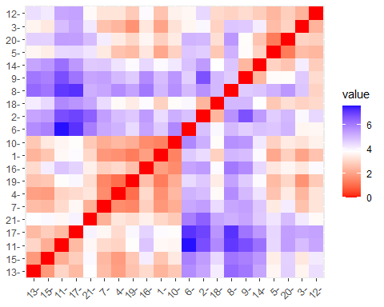
#scaling the data and using K-means clustering to organize it.
kmeans_R1 <- kmeans(Scaled_input_pharmaceuticals, centers = 5, nstart = 25)
#The graph visualization of the clusters
fviz_cluster(kmeans_R1, data = Scaled_input_pharmaceuticals)
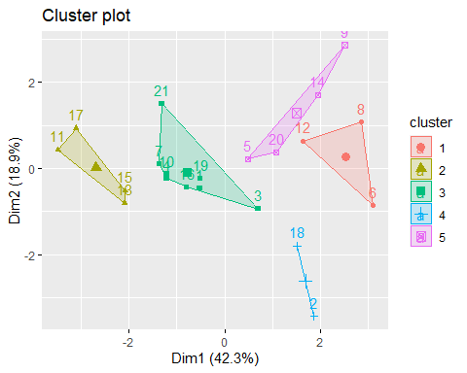
print(kmeans_R1)
## K-means clustering with 5 clusters of sizes 3, 4, 8, 2, 4
##
## Cluster means:
## Market_Cap Beta PE_Ratio ROE ROA Asset_Turnover
## 1 -0.87051511 1.3409869 -0.05284434 -0.6184015 -1.1928478 -0.4612656
## 2 1.69558112 -0.1780563 -0.19845823 1.2349879 1.3503431 1.1531640
## 3 -0.03142211 -0.4360989 -0.31724852 0.1950459 0.4083915 0.1729746
## 4 -0.43925134 -0.4701800 2.70002464 -0.8349525 -0.9234951 0.2306328
## 5 -0.76022489 0.2796041 -0.47742380 -0.7438022 -0.8107428 -1.2684804
## Leverage Rev_Growth Net_Profit_Margin
## 1 1.36644699 -0.6912914 -1.320000179
## 2 -0.46807818 0.4671788 0.591242521
## 3 -0.27449312 -0.7041516 0.556954446
## 4 -0.14170336 -0.1168459 -1.416514761
## 5 0.06308085 1.5180158 -0.006893899
##
## Clustering vector:
## [1] 3 4 3 3 5 1 3 1 5 3 2 1 2 5 2 3 2 4 3 5 3
##
## Within cluster sum of squares by cluster:
## [1] 15.595925 9.284424 21.879320 2.803505 12.791257
## (between_SS / total_SS = 65.4 %)
##
## Available components:
##
## [1] "cluster" "centers" "totss" "withinss" "tot.withinss"
## [6] "betweenss" "size" "iter" "ifault"
##OVERVIEW: K-means Clustering
##OverviewIn -Input on nine factors associated with each among the twenty-one pharmaceutical businesses can be obtained via the summary algorithm applied to the k-means data. There are five different clusters in all, each with five centroid points, and the numbers are 2, 3, 4, 4, 8, and 9.
##Question2.a) Interpret the clusters with respect to the numerical variables used in forming the clusters.
#charting the sum of the values vs the total number of clusters
fviz_nbclust(Scaled_input_pharmaceuticals, kmeans, method = "wss")
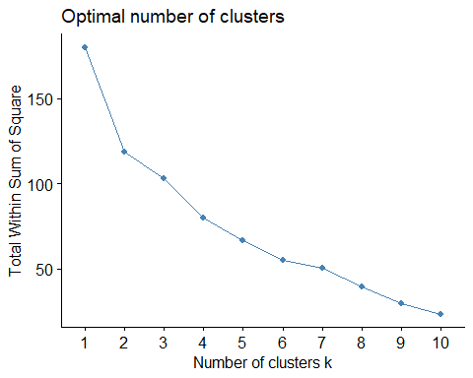 ## In this plot, it’s evident that the graph is not forming an elbow shape and is slightly flattening at k=4 and k=6.
#Plotting the amount of clusters will allow you to determine how many are optimum.
#compared to the typical silence width.
fviz_nbclust(Scaled_input_pharmaceuticals, kmeans, method = "silhouette")
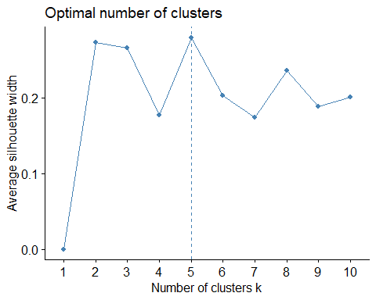 ##We can quickly determine that the most effective and most optimum option for this k-means clustering is 5 clusters based on the Silhoutte graph.
##Question 2.b) Is there a pattern in the clusters with respect to the numerical variables (10 to 12)? (those not used in forming the clusters).
#determining the mean value based on the data that is shown in the clusters.
#carrying out the pharmaceutical data’s aggregate functionality.
aggregate(input_pharmaceuticals[3:11], by=list(cluster=kmeans_R1$cluster), mean)
## cluster Market_Cap Beta PE_Ratio ROE ROA Asset_Turnover
## 1 1 6.636667 0.87000 24.6000 16.46667 4.166667 0.6000
## 2 2 157.017500 0.48000 22.2250 44.42500 17.700000 0.9500
## 3 3 55.810000 0.41375 20.2875 28.73750 12.687500 0.7375
## 4 4 31.910000 0.40500 69.5000 13.20000 5.600000 0.7500
## 5 5 13.100000 0.59750 17.6750 14.57500 6.200000 0.4250
## Leverage Rev_Growth Net_Profit_Margin
## 1 1.653333 5.733333 7.033333
## 2 0.220000 18.532500 19.575000
## 3 0.371250 5.591250 19.350000
## 4 0.475000 12.080000 6.400000
## 5 0.635000 30.142500 15.650000
#employ Cbind to do the data frame merging.
Short_term_data <- cbind(input_pharmaceuticals, cluster = kmeans_R1$cluster)
tibble(Short_term_data)
## # A tibble: 21 × 15
## Symbol Name Market_Cap Beta PE_Ratio ROE ROA Asset_Turnover Leverage
## <chr> <chr> <dbl> <dbl> <dbl> <dbl> <dbl> <dbl> <dbl>
## 1 ABT Abbott … 68.4 0.32 24.7 26.4 11.8 0.7 0.42
## 2 AGN Allerga… 7.58 0.41 82.5 12.9 5.5 0.9 0.6
## 3 AHM Amersha… 6.3 0.46 20.7 14.9 7.8 0.9 0.27
## 4 AZN AstraZe… 67.6 0.52 21.5 27.4 15.4 0.9 0
## 5 AVE Aventis 47.2 0.32 20.1 21.8 7.5 0.6 0.34
## 6 BAY Bayer AG 16.9 1.11 27.9 3.9 1.4 0.6 0
## 7 BMY Bristol… 51.3 0.5 13.9 34.8 15.1 0.9 0.57
## 8 CHTT Chattem… 0.41 0.85 26 24.1 4.3 0.6 3.51
## 9 ELN Elan Co… 0.78 1.08 3.6 15.1 5.1 0.3 1.07
## 10 LLY Eli Lil… 73.8 0.18 27.9 31 13.5 0.6 0.53
## # ℹ 11 more rows
## # ℹ 6 more variables: Rev_Growth <dbl>, Net_Profit_Margin <dbl>,
## # Median_Recommendation <chr>, Location <chr>, Exchange <chr>, cluster <int>
#Summarizing the particular beakdown by cluster
by(Short_term_data, factor(Short_term_data$cluster), summary)
## factor(Short_term_data$cluster): 1
## Symbol Name Market_Cap Beta
## Length:3 Length:3 Min. : 0.410 Min. :0.65
## Class :character Class :character 1st Qu.: 1.505 1st Qu.:0.75
## Mode :character Mode :character Median : 2.600 Median :0.85
## Mean : 6.637 Mean :0.87
## 3rd Qu.: 9.750 3rd Qu.:0.98
## Max. :16.900 Max. :1.11
## PE_Ratio ROE ROA Asset_Turnover Leverage
## Min. :19.90 Min. : 3.90 Min. :1.400 Min. :0.6 Min. :0.000
## 1st Qu.:22.95 1st Qu.:12.65 1st Qu.:2.850 1st Qu.:0.6 1st Qu.:0.725
## Median :26.00 Median :21.40 Median :4.300 Median :0.6 Median :1.450
## Mean :24.60 Mean :16.47 Mean :4.167 Mean :0.6 Mean :1.653
## 3rd Qu.:26.95 3rd Qu.:22.75 3rd Qu.:5.550 3rd Qu.:0.6 3rd Qu.:2.480
## Max. :27.90 Max. :24.10 Max. :6.800 Max. :0.6 Max. :3.510
## Rev_Growth Net_Profit_Margin Median_Recommendation Location
## Min. :-3.170 Min. : 2.600 Length:3 Length:3
## 1st Qu.: 1.605 1st Qu.: 5.050 Class :character Class :character
## Median : 6.380 Median : 7.500 Mode :character Mode :character
## Mean : 5.733 Mean : 7.033
## 3rd Qu.:10.185 3rd Qu.: 9.250
## Max. :13.990 Max. :11.000
## Exchange cluster
## Length:3 Min. :1
## Class :character 1st Qu.:1
## Mode :character Median :1
## Mean :1
## 3rd Qu.:1
## Max. :1
## ------------------------------------------------------------
## factor(Short_term_data$cluster): 2
## Symbol Name Market_Cap Beta
## Length:4 Length:4 Min. :122.1 Min. :0.3500
## Class :character Class :character 1st Qu.:129.9 1st Qu.:0.4325
## Mode :character Mode :character Median :153.2 Median :0.4600
## Mean :157.0 Mean :0.4800
## 3rd Qu.:180.3 3rd Qu.:0.5075
## Max. :199.5 Max. :0.6500
## PE_Ratio ROE ROA Asset_Turnover
## Min. :18.00 Min. :28.60 Min. :15.00 Min. :0.800
## 1st Qu.:18.68 1st Qu.:37.60 1st Qu.:15.97 1st Qu.:0.875
## Median :21.25 Median :43.10 Median :17.75 Median :0.950
## Mean :22.23 Mean :44.42 Mean :17.70 Mean :0.950
## 3rd Qu.:24.80 3rd Qu.:49.92 3rd Qu.:19.48 3rd Qu.:1.025
## Max. :28.40 Max. :62.90 Max. :20.30 Max. :1.100
## Leverage Rev_Growth Net_Profit_Margin Median_Recommendation
## Min. :0.100 Min. : 9.37 Min. :14.10 Length:4
## 1st Qu.:0.145 1st Qu.:15.36 1st Qu.:16.95 Class :character
## Median :0.220 Median :19.61 Median :19.50 Mode :character
## Mean :0.220 Mean :18.53 Mean :19.57
## 3rd Qu.:0.295 3rd Qu.:22.79 3rd Qu.:22.12
## Max. :0.340 Max. :25.54 Max. :25.20
## Location Exchange cluster
## Length:4 Length:4 Min. :2
## Class :character Class :character 1st Qu.:2
## Mode :character Mode :character Median :2
## Mean :2
## 3rd Qu.:2
## Max. :2
## ------------------------------------------------------------
## factor(Short_term_data$cluster): 3
## Symbol Name Market_Cap Beta
## Length:8 Length:8 Min. : 6.30 Min. :0.1800
## Class :character Class :character 1st Qu.:44.67 1st Qu.:0.2875
## Mode :character Mode :character Median :59.48 Median :0.4800
## Mean :55.81 Mean :0.4138
## 3rd Qu.:69.79 3rd Qu.:0.5125
## Max. :96.65 Max. :0.6300
## PE_Ratio ROE ROA Asset_Turnover
## Min. :13.10 Min. :14.90 Min. : 7.80 Min. :0.5000
## 1st Qu.:17.65 1st Qu.:21.43 1st Qu.:11.65 1st Qu.:0.6000
## Median :21.10 Median :26.90 Median :13.35 Median :0.7500
## Mean :20.29 Mean :28.74 Mean :12.69 Mean :0.7375
## 3rd Qu.:22.38 3rd Qu.:31.95 3rd Qu.:13.90 3rd Qu.:0.9000
## Max. :27.90 Max. :54.90 Max. :15.40 Max. :0.9000
## Leverage Rev_Growth Net_Profit_Margin Median_Recommendation
## Min. :0.0000 Min. :-2.690 Min. :11.20 Length:8
## 1st Qu.:0.0450 1st Qu.: 2.115 1st Qu.:17.23 Class :character
## Median :0.3450 Median : 6.630 Median :19.30 Mode :character
## Mean :0.3713 Mean : 5.591 Mean :19.35
## 3rd Qu.:0.5400 3rd Qu.: 7.795 3rd Qu.:22.65
## Max. :1.1200 Max. :15.000 Max. :25.50
## Location Exchange cluster
## Length:8 Length:8 Min. :3
## Class :character Class :character 1st Qu.:3
## Mode :character Mode :character Median :3
## Mean :3
## 3rd Qu.:3
## Max. :3
## ------------------------------------------------------------
## factor(Short_term_data$cluster): 4
## Symbol Name Market_Cap Beta
## Length:2 Length:2 Min. : 7.58 Min. :0.4000
## Class :character Class :character 1st Qu.:19.75 1st Qu.:0.4025
## Mode :character Mode :character Median :31.91 Median :0.4050
## Mean :31.91 Mean :0.4050
## 3rd Qu.:44.08 3rd Qu.:0.4075
## Max. :56.24 Max. :0.4100
## PE_Ratio ROE ROA Asset_Turnover Leverage
## Min. :56.5 Min. :12.90 Min. :5.50 Min. :0.600 Min. :0.3500
## 1st Qu.:63.0 1st Qu.:13.05 1st Qu.:5.55 1st Qu.:0.675 1st Qu.:0.4125
## Median :69.5 Median :13.20 Median :5.60 Median :0.750 Median :0.4750
## Mean :69.5 Mean :13.20 Mean :5.60 Mean :0.750 Mean :0.4750
## 3rd Qu.:76.0 3rd Qu.:13.35 3rd Qu.:5.65 3rd Qu.:0.825 3rd Qu.:0.5375
## Max. :82.5 Max. :13.50 Max. :5.70 Max. :0.900 Max. :0.6000
## Rev_Growth Net_Profit_Margin Median_Recommendation Location
## Min. : 9.16 Min. :5.50 Length:2 Length:2
## 1st Qu.:10.62 1st Qu.:5.95 Class :character Class :character
## Median :12.08 Median :6.40 Mode :character Mode :character
## Mean :12.08 Mean :6.40
## 3rd Qu.:13.54 3rd Qu.:6.85
## Max. :15.00 Max. :7.30
## Exchange cluster
## Length:2 Min. :4
## Class :character 1st Qu.:4
## Mode :character Median :4
## Mean :4
## 3rd Qu.:4
## Max. :4
## ------------------------------------------------------------
## factor(Short_term_data$cluster): 5
## Symbol Name Market_Cap Beta
## Length:4 Length:4 Min. : 0.780 Min. :0.2400
## Class :character Class :character 1st Qu.: 1.095 1st Qu.:0.3000
## Mode :character Mode :character Median : 2.230 Median :0.5350
## Mean :13.100 Mean :0.5975
## 3rd Qu.:14.235 3rd Qu.:0.8325
## Max. :47.160 Max. :1.0800
## PE_Ratio ROE ROA Asset_Turnover
## Min. : 3.60 Min. :10.20 Min. :5.100 Min. :0.300
## 1st Qu.:14.70 1st Qu.:10.95 1st Qu.:5.325 1st Qu.:0.300
## Median :19.25 Median :13.15 Median :6.100 Median :0.400
## Mean :17.68 Mean :14.57 Mean :6.200 Mean :0.425
## 3rd Qu.:22.23 3rd Qu.:16.77 3rd Qu.:6.975 3rd Qu.:0.525
## Max. :28.60 Max. :21.80 Max. :7.500 Max. :0.600
## Leverage Rev_Growth Net_Profit_Margin Median_Recommendation
## Min. :0.200 Min. :26.81 Min. :12.90 Length:4
## 1st Qu.:0.305 1st Qu.:28.59 1st Qu.:13.20 Class :character
## Median :0.635 Median :29.77 Median :14.20 Mode :character
## Mean :0.635 Mean :30.14 Mean :15.65
## 3rd Qu.:0.965 3rd Qu.:31.33 3rd Qu.:16.65
## Max. :1.070 Max. :34.21 Max. :21.30
## Location Exchange cluster
## Length:4 Length:4 Min. :5
## Class :character Class :character 1st Qu.:5
## Mode :character Mode :character Median :5
## Mean :5
## 3rd Qu.:5
## Max. :5
#median the calculation
Commend_tables <- table(Short_term_data$cluster, Short_term_data$Median_Recommendation)
names(dimnames(Commend_tables)) <- c("Cluster", "Recommendation")
Commend_tables <- addmargins(Commend_tables)
Commend_tables
## Recommendation
## Cluster Hold Moderate Buy Moderate Sell Strong Buy Sum
## 1 2 1 0 0 3
## 2 2 2 0 0 4
## 3 4 1 2 1 8
## 4 1 1 0 0 2
## 5 0 2 2 0 4
## Sum 9 7 4 1 21
##There are 21 suggestions in total: one strong buy, seven moderate buys, nine holds, and four moderate sells. Cluster 5 combines all four suggestions, including the opposing advise on buys and sells. Clusters 1, 2, and 3 only include information about mod purchases and holds.For Cluster 4, there is a moderate buy and a moderate sell suggestion.
#Cluster breakdown of the organization’s headquarters based on the combined data.
Loctn_Table <- table(Short_term_data$cluster, Short_term_data$Location)
names(dimnames(Loctn_Table)) <- c("Cluster", "Location")
Loctn_Table <- addmargins(Loctn_Table)
Loctn_Table
## Location
## Cluster CANADA FRANCE GERMANY IRELAND SWITZERLAND UK US Sum
## 1 0 0 1 0 0 0 2 3
## 2 0 0 0 0 0 1 3 4
## 3 0 0 0 0 1 2 5 8
## 4 1 0 0 0 0 0 1 2
## 5 0 1 0 1 0 0 2 4
## Sum 1 1 1 1 1 3 13 21
##There are a total of 21 firms: 13 are located in the United States, 3 in the United Kingdom, and 1 in each of Canada, France, Germany, Ireland, and Switzerland. Cluster 5 features the US, UK, and Switzerland. Cluster 2 has the US and Canada. Cluster 3 features the US and Britain. Cluster 4 features the US, France, and Ireland.
#pulling up a summary each of the cluster’s stock exchange values.
#establishing the exchange table and generating a data frame for the combined information.
Exg_Tables <- table(Short_term_data$cluster, Short_term_data$Exchange)
names(dimnames(Exg_Tables)) <- c("Cluster", "Exchange")
Exg_Tables <- addmargins(Exg_Tables)
Exg_Tables
## Exchange
## Cluster AMEX NASDAQ NYSE Sum
## 1 1 1 1 3
## 2 0 0 4 4
## 3 0 0 8 8
## 4 0 0 2 2
## 5 0 0 4 4
## Sum 1 1 19 21
##In total, there are 21 companies: 1 Amex, 1 Nasdaq, and 19 NYSE. Just the NYSE is in Cluster 5. Cluster 2 includes all three. The only thing in clusters 1, 3, and 4 is NYSE.
##Question 3.) Provide an appropriate name for each cluster using any or all of the variables in the dataset.
Answers :- Cluster 1: - All US firms listed on the NYSE that are either held or purchased make up Cluster 1: “High Market Cap - High RoE” greater NetProfitMargin.
Cluster 2: This cluster, which includes exclusively NYSE-listed businesses, is dubbed “Hold CLuster”
Cluster 3: This is called “Low Market Cap & Less ROA”; on stock exchanges, it is either buy or hold.
Cluster 4:This fits under the heading of “High PE ratio / Small Net Profit Margin.”.
Cluster 5: The moniker “Moderate Buy & Moderate Sell” might be used to this cluster.
##Trying or investigating alternative techniques to determine if they may provide more effective clustering as well?
fviz_nbclust(range_input_pharmaceuticals, FUN = kmeans, method = "silhouette")

kmeans_R2 = kcca(Scaled_input_pharmaceuticals, k=5, kccaFamily("kmeans"))
kmeans_R2
## kcca object of family 'kmeans'
##
## call:
## kcca(x = Scaled_input_pharmaceuticals, k = 5, family = kccaFamily("kmeans"))
##
## cluster sizes:
##
## 1 2 3 4 5
## 4 3 4 4 6
clusters(kmeans_R2)
## [1] 2 4 5 1 5 4 1 4 5 2 3 5 3 5 3 2 3 4 1 5 1
#Using the technique of predict().
index_clusters <- predict(kmeans_R2)
image(kmeans_R2)
points(Scaled_input_pharmaceuticals, col=index_clusters, pch=9, cex=1.0)
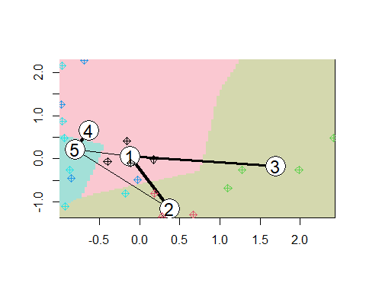 ##In this instance, the kcca method is utilized to perform a kmeans cluster on k = 5, as opposed to the kmeans function from basic R. In comparison to the base R method, the clustering has the same size but a distinct assignment between the points. The clustering graph shows that there is more ambiguity in the grouping than we would want, especially between groups 1, 2, and 3.
PLOTTING THE CLUSTERS AND THE KMEDIANS.
kmeans_R2 = kcca(Scaled_input_pharmaceuticals, k=5, kccaFamily("kmedians"))
kmeans_R2
## kcca object of family 'kmedians'
##
## call:
## kcca(x = Scaled_input_pharmaceuticals, k = 5, family = kccaFamily("kmedians"))
##
## cluster sizes:
##
## 1 2 3 4 5
## 4 5 3 3 6
clusters(kmeans_R2) #clusteing
## [1] 5 1 5 5 2 1 5 1 2 3 4 1 5 2 4 3 4 2 5 2 3
index_clusters <- predict(kmeans_R2)
image(kmeans_R2)
points(Scaled_input_pharmaceuticals, col=index_clusters, pch=9, cex=1.0)
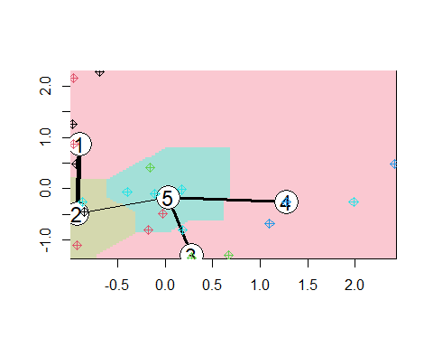 ##The sizes of the five clusters are 4, 5, 3, 3, and 6 if we convert the KCC to Kmedian from Kmeans. However, the clustering is less pronounced. Though it’s uncertain if a better cluster exists, we plan to look into the additional data to see if there are any other methods or resources we might employ to improve the visual cluster.

